Rewiring food webs through trophic rewilding

Emilio Berti1, 2, *, Scott Jarvie1, 2,, and Jens-Christian Svenning1, 2

1 Section for Ecoinformatics and Biodiversity, Department of Biology, Aarhus University, Ny Munkegade 114, DK-8000 Aarhus C, Denmark.

2 Center for Biodiversity Dynamics in a Changing World (BIOCHANGE), Department of Biology, Aarhus University, Ny Munkegade 114, DK-8000 Aarhus C, Denmark.

* Corresponding author:

* e-mail: [emilio.berti@bios.au.dk](mailto:emilio.berti@bios.au.dk)
* ORCiD: <https://orcid.org/0000-0001-9286-011X>

## Keywords

Food webs; Human-driven extinctions; Mammals; Megafauna; Rewilding; Trophic interactions.

## Abstract

Human pressure caused massive extinctions during the Late Pleistocene, with a selective size-bias towards large mammals, causing the loss of top-down trophic forces and degrading trophic complexity of ecosystems worldwide. Trophic rewilding, the (re)introduction of species to promote self-sustaining biodiverse ecosystems, has been proposed as a strategy to restore trophic structure in ecosystems. Yet the extent of restoration possible via trophic rewilding is poorly understood. Here, we combined estimates of species geographic ranges without anthropogenic pressure with species distribution models and food web models to quantify past losses and potential recoveries through rewilding. Our results show that food webs have been degraded by human activities: the number of species in all trophic levels reduced on average by 41%, with an average decrease of interactions among levels of 51%. We also found that a conservative rewilding approach can largely rewire food webs and partly restore trophic complexity in ecosystems: the number of species in trohpic levels recovered on average by 11%, while the average number of predator-prey interactions by 18%. Overall, our findings support rewilding as a novel opportunity to rewire food webs and reinstate lost trophic interactions in degraded ecosystems. Humans have defaunated ecosystems and reduced trophic complexity of food webs worldwide, causing widespread biodiversity crises. Yet, recoveries from such losses are possible through trophic rewilding, which can restore trophic complexity in food webs and promote biodiverse self-sustaining ecosystems.

# Introduction

Humans have caused extinction of species and their interactions, altering ecological processes that degraded ecosystems worldwide (Dirzo et al. 2014, Valiente-Banuet et al. 2015)⁠. Human-driven extinctions and extirpations of mammals date back to the Late Pleistocene (starting 130,000 years ago), with a large bodied size-selectivity causing extinctions of many megafauna species (121 out of 196 genera ≥ 45 kg have gone extinct; (Barnosky 2008, Smith et al. 2018)⁠⁠. Humans have thus removed interactions from ecological networks for many millenia, simplifying the trophic complexity of pre-human biodiverse megafauna communities (Gill 2014)⁠. These losses reduced top-down control, i.e. the regulatory effects of higher trophic levels to lower levels, and modified trophic cascades, affecting the biodiversity and the resilience of ecosystems (Estes et al. 2011, Svenning et al. 2016)⁠.

Trophic rewilding, the (re)introduction of species to promote self-sustaining biodiverse ecosystems (Svenning et al. 2016)⁠, has been proposed to re-establish lost ecological interactions (Perino et al. 2019)⁠. After wolves were reintroduced in the Yellowstone National Park, for example, top-down effects on herbivores density and behavior partly re-established trophic cascades that promoted forest regeneration (Beschta and Ripple 2016)⁠. Yet, empirical data from rewilding projects are scarce and geographically biased (Tanentzap and Smith 2018)⁠, with the scientific literature dominated by essays, perspectives and opinion papers (Bakker and Svenning 2018)⁠. Thus, despite the restoration potential of rewilding is supported by local studies (Perino et al. 2019)⁠, there is still limited knowledge of the potential of rewilding to rewire ecological networks at a global scale.

Alternative to local experiments, a theoretical approach can provide insights on the potential of trophic rewilding to rewire ecological networks at large scales with deep-time perspectives. For instance, functional similarities between species can be highlighted by comparing their traits, suggesting functional analogues to replace globally extinct species and rewild ecosystems (Pires 2017)⁠. Moreover, species distribution and their biotic interactions can be reconstructed through theoretical models (Yeakel et al. 2014, Pires et al. 2015)⁠, which can be used to assess the effects of human-driven extinctions and of possible rewilding scenarios on ecological networks (Marjakangas et al. 2018, Emer et al. 2019)⁠.

In this study, we investigate the potential of rewilding to rewire terrestrial mammal food webs in large (≥ 5,000 km2) protected areas at a global scale (Fig. 1). Moreover, because protected areas are localized in regions that poorly cover current mammal biodiversity hotspots (Joppa and Pfaff 2009)⁠, we assessed if results from protected areas were affected by geographic biases by analysing also random areas evenly distributed on the continents (Fig. 1). For each area, we infer food webs, ecological networks describing direct predator-prey interactions, under three scenarios: 1) present-natural, a counter-factual scenario where mammals have not been influenced by human activities through time (Faurby and Svenning 2015, Faurby et al. 2018)⁠; 2) current; and 3) rewilding, where extant species can be reintroduced to present-natural ranges and extinct species can be replaced by closely-related, similarly-sized functional analogues that have similar climatic niches. We then compare the food webs for the three scenarios and investigate the effects of human pressure on the number of species and predator-prey interactions in current food webs and whether rewilding can rewire food webs to present-natural conditions.

# Methods

## Overview

Expanding upon the terminology of (Genes et al. 2017)⁠, we quantified: a) current debt, the number of species and interactions lost due to Late Pleistocene extinctions and extirpations of mammals; b) rewilding credit, the number of species and interactions restored under the rewilding scenario; and c) rewilding deficit, the losses that cannot be restored by rewilding. After quantifying current debt, rewilding credit, and rewilding deficit, we assessed whether rewilding credit can balance current debt or rewilding deficit remained significant and food webs were not completely restored to present-natural conditions.

We assessed the potential of rewilding to restore food webs to present-natural levels in large protected areas with strict International Union for Conservation of Nature (IUCN) management categories (Ia: strict nature reserves; Ib: wilderness areas; and II: national parks). We pragmatically defined, for the purposes of the analyses, large protected areas as areas ≥ 5,000 km2, a realistic trade-off between possibly over-conservative cut-offs (e.g. 25,000 km2 for very large protected areas; Cantú-Salazar and Gaston 2010)⁠ and too optimistic thresholds (e.g. 100 km2 for small protected areas; Ripple et al. 2015⁠). We selected protected areas ≥ 5,000 km2 with IUCN management I-II as they represent the sites were trophic rewilding is likely more feasible today, being them geographically isolated and with strictly-controlled human access (Dudley et al. 2013) and large enough to sustain viable megafauna populations (Woodroffe and Ginsberg 1998, Cantú-Salazar and Gaston 2010, Ripple et al. 2015)⁠. Spatial geometries of protected areas were downloaded from the World Database of Protected Area (UNEP-WCMC & IUCN 2019, downloaded June 2019). Following previous global studies (Runge et al. 2015)⁠, we excluded protected areas without detailed geographic information, with unknown management status, not considered protected areas internationally, UNESCO Biosphere Reserves, and marine-only sites as well as the marine portion of coastal sites. We then dissolved adjacent geometries and excluded areas with extent < 5,000 km2. We found 209 protected areas that met our requirements (Fig. 1).

Because protected areas ≥ 5,000 with IUCN management categories I-II are unevenly distributed on the continents (Fig. 5) and poorly overlap with current mammal biodiversity hotspots (Joppa and Pfaff 2009, Daru et al. 2019), we also assessed the potential of rewilding to restore food webs in random areas that did not have the geographic biases of protected areas (Fig. 1). We thus quantified current debts, rewilding credit and deficit in areas randomly scattered across Earth’s terrestrial surface to investigate if results from protected areas were affected by their geographic biases. In particular, we randomly generated 37 areas of 40 km radius (area ≃ 5,026 km2) for each biogeographic realms, large terrestrial land masses that delineate areas where ecological and evolutionary processes operate most strongly (Olson et al. 2001, Olson and Dinerstein 2002)⁠. We excluded from analyses the Antarctic realm, as no terrestrial mammal have ever lived there, and the Oceania realm, which did not have any large protected areas that met our requirements. Moreover, we generated 15 of the 37 random areas for the Palearctic realm within Europe (excluding Russia), to make sure to have an appropriate sample representing this . . . . As random areas were used to assess the effects of past losses and the restoration potential of rewilding without geographic biases, we did not impose further restrictions to their location. Random areas could thus be located in places where rewilding might be unlikely, e.g. area with high human densities. Results from random areas are thus useful for highlighting possible biases in the analysis of protected areas, but they do not reflect real-world applications of rewilding when considered alone. In total, we found 206 random areas for which we could reconstruct food webs, excluding thus 16 areas that did not have terrestrial mammals or for which predator-prey interactions were not recorded and could not be inferred by our model.

Our modelling methodology includes four distinct steps: 1) we ran correlative species distribution models (SDMs) for extant terrestrial mammals to estimate their climatically suitable habitats; 2) we modelled reintroductions of extant terrestrial mammals and identified extant mammals that can be used to replace closely-related, similarly-sized extinct species in climatically suitable habitats; 3) we reconstructed food webs within the protected and the random areas for the present-natural, current, and rewilding scenarios; and 4) we contrasted the food webs of the three scenarios and investigated whether rewilding can rewire current food webs to present-natural conditions. These four steps are summarised below; more details are provided in the supplementary material.

### Species distribution models

Correlative SDMs are currently the main tools used to derive spatially explicit predictions of environmental suitability for species (Elith and Leathwick 2009)⁠. In general, statistical relationships between species observations and environmental descriptors are identified and used to predict the climatic suitability of species in geographic space (Guisan and Thuiller 2005)⁠. Following previous studies (Jarvie and Svenning 2018)⁠, we used current and present-natural range maps from the PHYLACINE database (Faurby et al. 2018)⁠ to overcome biases in the SDMs due to anthropogenic range contraction of species (Faurby and Araújo 2018)⁠. PHYLACINE current ranges were generated from the IUCN range maps for current, natural, and reintroduced ranges only (IUCN 2019). Present-natural ranges are estimates of where species could be today in the complete absence of influence of modern humans (*Homo sapiens*) through time and were derived using known historic distributions of species, fossil co-occurrence data, and known range modifications caused by humans (Faurby and Svenning 2015)⁠. By using both current and present-natural ranges we thus limited biases in species occurrence records due to anthropogenic modification of species distribution ranges (Faurby and Araújo 2018)⁠. We generated presence locations within combined current and present-natural range maps with a 20 km separation distance, excluding locations reported above the highest elevation for each species in the IUCN or, if not stated, 4,000 meters, which is roughly the 95 percentile for upper elevations of mammals (IUCN 2019). Elevation was determined for presence locations using the EarthEnv-DEM90 digital elevation model (Robinson et al. 2014)⁠. We only modelled species with at least 10 presence locations, thus excluding 76 rare endemic species. In total, we modelled 4,130 of the 4,206 living terrestrial mammals.

As environmental predictors for the SDMs, we used four bioclimatic variables from the WorldClim database at 2.5 arc-minute resolution (Fick and Hijmans 2017)⁠ reprojected to Behrmann equal-area projection at 25 km2 resolution using bilinear interpolation. Because temperature and precipitation extremes are the main factors limiting the distribution of terrestrial mammals (Guisan et al. 2017)⁠, we chose as predictors for the SDMs the four bioclimatic variables: maximum temperature of the warmest month, minimum temperature of the coldest month, precipitation of wettest quarter, and precipitation of driest quarter. To minimize potential issues with multi-collinearity, we ensured that the variance inflation factor among the climatic variables was below 4 (O’Brien 2007)⁠.

To model the climatic suitability of terrestrial mammals, we fitted maximum entropy (Maxent) models as implemented in the R package maxnet (Phillips et al. 2017)⁠. Maxent is a presence-background approach, in which environments occupied by a species are contrasted with the available environmental space (Elith et al. 2011, Merow et al. 2013)⁠. We ran Maxent SDMs with the default settings, besides disabling threshold features to avoid locally overfitted response curves (Merow et al. 2013, 2014)⁠. We also increased the number of randomly sampled background records from the default setting of 10,000 to 100,000 to ensure greater representation of environmental variables available within background areas (Guevara et al. 2018)⁠. For the background area, we calculated species-specific buffers from combined current and present natural ranges to reflect the dispersal abilities of each species (Barve et al. 2011)⁠. Following previous studies (Poo-Muñoz et al. 2014, Hof et al. 2018)⁠, we calculated the buffer size as the maximum distance from the centroid to the edge of the largest continuous range (see Supplementary Fig. 1 for an example).

We assessed the predictive performance of Maxent SDMs through five-fold cross validation using the average Continuous Boyce Index (CBI; Hirzel et al. 2006), which indicates how much models discriminate against random expectation, and the average Area Under the Curve (AUC) of the receiver operating plot (AUC; Swets 1988⁠⁠), which indicates how well models differentiate between presences and pseudo-absences regardless of the degree of difference between them. Values of CBI range between -1 and 1, where values > 0 indicate the model's output is positively correlated with the true probability of presence and values < 0 indicate it is negatively correlated with the true probability of presence. AUC values range from <= 0.5 for models with discrimination no better than random to 1 for models with perfect discrimination between occupied and unoccupied places (Fielding and Bell 1997)⁠. Model fit was inspected by five-fold cross validation of the average omission rate based on the minimum training presence value (ORMTP; Radosavljevic and Anderson 201)⁠). The values of ORMTP range from 0 for models that are not overfit to 1 for models that are overfit. To convert continuous suitability predictions to binary layers indicating suitable/unsuitable habitat, we used as threshold the suitability value that maximised sensitivity and specificity (Maximum Sensitivity and Specificity; MSS), which is more reliable than other threshold metrics when only presence data are available (Liu et al. 2016)⁠. We also assessed the performance of Maxent SDMs by comparing projected climatic suitabilities with 136 known introduction ranges of species obtained from Lundgren et al. (2018; n = 22 species) and the IUCN (IUCN 2019; n = 114 species). For three species found in both datasets (*Cervus elaphus*, *Ovibos moschatus*, and *Rangifer tarandus*), we assessed performance of Maxent SDMs using only the ranges from Lundgren et al. (2018)⁠.

Predictive performance of Maxent SDMs was on average very high to excellent (mean AUC = 0.85; mean CBI = 0.87), while model overfitting was generally low (mean ORMTP = 0.07; see Supplementary Table 1 for further details). On average, 62% of the introduction ranges from Lundgren et al. (2018)⁠ and IUCN (2019) was predicted by Maxent SDMs (Supplementary Fig. 2). Overall, Maxent SDMs showed good predictive performance and low overfit and gave thus reliable projections of climatic suitability of terrestrial mammals.

## Scenarios (Selection of rewilding functional analogues)

To investigate the potential of rewilding to restore food webs, we studied three scenario: the present-natural, a counter-factual scenario for present time where mammals have not been influenced by human activities through time (Faurby and Svenning 2015)⁠, i.e. without species extinctions and range modification due to humans; current conditions; and rewilding, a counter-factual scenario where extant mammals can be reintroduced into their present-natural ranges and extinct species can be replaced by closely-related, similarly-sized functional analogues.

For the rewilding scenario, we selected rewilding candidates and functional analogues following two steps: 1) we modelled where extant terrestrial mammals can be reintroduced into their present-natural ranges; 2) we identified extant mammals that can be used as functional analogues to replace closely-related, similarly-sized extinct species in climatically suitable habitats. Reintroductions of extant mammals were always prioritised over introductions of functional analogues. This was done to minimize the ecological risk in the introduction of species outside their indigenous ranges, inherently riskier than species reintroduction due to unforeseeable uncertainties (Fernández et al. 2017). To further minimize ecological risk and make sure the ecological role of extinct species and functional analogues were similar, we constrained potential replacements to be from the same family of the extinct species and within the 50% body mass range of the extinct species. … we made two exceptions: 1) extinct megaherbivore (𢁥≥ 1,000 kg; Malhi et al., 2016) from the Proboscidea order were allowed to be replaced by the two extant elephants (*Elephas maximus* and *Loxodonta africana*). The rationale of this being that extant elephants are often considered as functional analogues of extinct megaherbivore proboscidean in many areas of the globe (Donlan 2005, Donlan et al. 2006, Svenning 2007)⁠, due to their general phenotypic similarity (large body size, tusks, trunk) and because they promote similar key ecosystem processes, e.g., nutrient cycles and vegetation clearing(Janzen and Martin 1982, Donlan et al. 2006)⁠; 2) extinct Felidae and Ursidae megacarnivores (≥ 100 kg; Malhi et al. 2016) were allowed to be replaced by extant megacarnivores of the same family, as megacarnivores regulate abundance and activity of large herbivores (Laundre et al. 2010, Ripple et al. 2014)⁠, necessary to restore trophic complexity in self-sustaining ecosystems (Perino et al. 2019)⁠. For functional analogues, we examined each biogeographic realm separately due to these being areas where ecological and evolutionary processes operate strongly (Olson et al. 2001, Olson and Dinerstein 2002)⁠. We excluded Antarctica because no terrestrial mammal lives there and Oceania because no strictly managed IUCN protected areas ≥ 5,000 km2 are found there (Figure 1).

To avoid negative impacts from introductions of functional analogues into present-natural ranges of similarly-sized – i.e., within 50% of the body mass – extant species of the same taxonomic group, we excluded the functional analogue to prevent potential issue due to competition between two species (Linnell and Strand 2000)⁠. For the remaining functional analogues, we selected the species that had the largest climatically suitable range overlapping within the present-natural range of the extinct species in each biogeographic realm. We did not select species for rewilding that violated any of the above conditions. See Supplementary Fig. 3 for a schematic representation for the selection of functional analogue. In total, we found 94 living species that can act as functional analogues to replace 127 of the 334 terrestrial mammals extinct during the Late Pleistocene (Supplementary Table #).

## Reconstructed food webs

We estimated present-natural and current predator-prey communities using present-natural and current ranges from the PHYLACINE database, respectively. To estimate the rewilding communities, we combined the present-natural ranges of extant mammals, simulating species reintroductions, their current ranges, and the rewilding ranges for the selected functional analogues that replaced closely-related, similarly sized extinct species. Rewilding ranges were always constrained to areas where extant species were found to be climatically suitable, assessed using Maxent SDMs (see Supplementary Fig. 4 for an example).

We inferred food webs, ecological networks describing direct predator-prey interactions, for each protected and random areas by combining a phylogenetic method with a trait-based approach (Pomeranz et al. 2019)⁠. Phylogeny has been shown to be a good predictor of trophic interactions (Eklöf et al. 2012)⁠, as closely related species share similar resources (Gray et al. 2015)⁠. We performed phylogenetic inference at the family level, a reasonable trade-off between accuracy of predictions and data availability (Gray et al. 2015)⁠, and assigned each known interaction between a prey and a predator to all species of the respective families. Data of predator-prey interactions was obtained from the ECOWeB database (Cohen 2010), the Global Biotic Interactions database (GLOBI; Poelen et al. 2014⁠), and two published food webs (Baskerville et al. 2011, De Visser et al. 2011)⁠. We then used a trait-based approach to remove interactions inferred using phylogeny that were not supported by macroecological evidence (Pomeranz et al. 2019)⁠. This trait-based approach uses the relationship between the body mass of prey and predators, which structures trophic interactions in food webs (Williams and Martinez 2000, Owen-Smith and Mills 2008, Segura et al. 2016)⁠. Following previous studies (Gravel et al. 2013, Pomeranz et al. 2019)⁠, we used the range within the 10% and the 90% regression quantiles to obtain dietary niches of carnivores, i.e. the body mass range of their prey. Phylogenetically inferred predator-prey interactions outside the dietary niche were removed from the food webs.

After food webs were inferred, we used the herbivore-carnivore definition of Malhi et al. (2016) to assign species to a trophic level according to their diet and body mass, as this reflects the trophic and ecological role of species (Malhi et al. 2016)⁠. For carnivores, we divided them into three trophic levels: i) megacarnivores >= 100 kg, which are generally apex predators that dominate food webs; ii) large carnivores 21.5–99 kg, which can predate on large prey and are subjected to top-down control from megacarnivores; and iii) small carnivores < 21.5 kg, which can predate only on smaller prey (Carbone et al. 1999). For herbivores, we also used three trophic levels: i) megaherbivores >= 1,000 kg, which are mostly free from predation; ii) large herbivores 45–999 kg, which are predated only by large carnivores and megacarnivores; and iii) small herbivores < 45 kg, which are predated by all carnivore trophic levels (Hopcraft, Olff, & Sinclair, 2010).

## Statistical analyses

For the three food web scenarios, we calculated for each protected and random area the number of species present in each trophic level and the number of predator-prey interactions connecting trophic levels. We then fitted generalised linear mixed models (GLMMs) using the protected and random areas as replicate sample units to compare the changes between scenarios. Specifically, we estimated: current debts, i.e. the differences between current and present-natural; rewilding credit, i.e. the differences between rewilding and current; and rewilding deficit, i.e. the differences between rewilding and present-natural.

We selected the error distribution for the GLMMs based on the response data type and to remedy overdispersion (Zuur et al. 2009). We used a Poisson distribution to model the number of species at each trophic level with the fixed effects scenario, trophic level, and their interaction. A negative binomial distribution was used to model the predator-prey interactions across trophic levels with the fixed effects scenario, trophic levels involved in the link, and their interaction. Because preliminary analyses showed random areas had in general lower numbers of species and interactions than protected areas (*P* < 0.05), we analysed protected and random areas separately. For GLMMs, we used the random effects food web ID and biogeographic realm. We assessed significance among scenarios by performing pair-wise contrasts with Bonferroni correction, with overall significance set at *P* < 0.05. We checked model assumptions were met for GLMMs through inspection of the residuals (Zuur et al. 2009). We assessed GLMMs goodness-of-fit by calculating the marginal R2, the proportion of variance in the data explained by only the fixed effects, and the conditional R2, the proportion of variance in the data explained by both fixed and random effects (Nakagawa & Schielzeth 2013). GLMMs had in general very good fit, explaining on average 67% of the variance in the data when only fixed effect was considered and 95% of the variance when also the random effect was included.

To estimate the magnitude of the change between scenarios, we calculated Cohen’s *d* effect size, assessing thus whether significant differences were also ecologically meaningful (Nakagawa & Schielzeth, 2010). We estimated Cohen’s *d* as the standardized difference between GLMMs estimates and defined, following Cohen (1988) and Sawilowsky (2009), the ecological relevance of the change as: very small (*d* = 0.00–0.20), small (*d* = 0.20–0.49), medium effect sizes (*d* = 0.50–0.79), large (*d* = 0.80–1.20 ), very large (*d* = 1.20–2.00), and huge (*d* ≥ 2.00).

Data processing and analyses were performed in the R programming language version 3.6.1 (R Core Team, 2018). We used package maxnet (Phillips 2017) to model climatic suitability of species, quantreg (Koenker 2019) to perform quantile regression on the dietary niches of predators, and modelbased (Makowski et al. 2019) All spatial analyses were conducted using the Behrmann cylindrical equal-area projection. Biogeographic realms were derived using the shapefile from the World Wildlife Foundation (WWF; Olson et al., 2001). Figures were made using packages ggplot2 (Wickham, 2016) with maps displayed in the Molleweide projection.

# Results

In the protected areas, we found a significantly lower number of species in trophic levels under current conditions than in the present-natural scenario except for small herbivores and small carnivores (Table 1). The number of megacarnivores decreased on average from 2.07 to 0.60 (Fig. 2); despite the relatively small difference, the effect size of this change was very large, indicating the decrease was ecologically important. Megaherbivores also declined of a relatively small but with very large effect size difference, declining on average from 2.82 to 0.47 in numbers. Numbers of large carnivores slightly decreased from 3.66 to 2.58, but with small effect size, indicating their declines had minor ecological effects. Average numbers of large herbivores decreased from 8.91 to 3.92, a difference with large effect size. Small carnivores numbers slightly decreased on average from 22.4 to 21.1, but with very small effect size, indicating negligible ecological effects. Small herbivores did not declined significantly and their average number remained constant at around 28.05.

Under the rewilding scenario, the number of species increased for megacarnivores to 1.09 (medium effect size), for megaherbivores to 0.87 (medium effect size), for large herbivores to 5.44 (small effect size), but did not change for large carnivores, small carnivores and small herbivores (Table 1). The number of species in the rewilding scenario was not completely restored to present-natural levels, but there were statistically significant differences. In particular, the numbers remained significantly lower for megacarnivores (medium effect size), for megaherbivores (large effect size), for large carnivores (small effect size), and for large herbivores (small effect size).

In the random areas, we observed similar patterns, but with stronger effect sizes showing more intense declines in the number of species from present-natural to current conditions and larger recoveries from current to rewilding scenario (Table1, Fig. 2). The relative amount of the number of species compared to present-natural remained, however, at similar proportions for all trophic levels in both protected and random areas, as shown by the similar effect sizes. Only large carnivores recovered more strongly in the random areas (medium effect size) compared to protected areas (small effect size). Overall, current debts and rewilding credit were both higher in random than in protected areas, whereas rewilding deficits were mostly comparable.

Among trophic levels, we found the numbers of predator-prey interactions decreased between present-natural and current conditions in protected areas (Table 2). All interactions where the predators were megacarnivores significantly decreased (Fig. 3). In particular, the number predator-prey interactions between megacarnivores and large carnivores were reduced from an average of 2.33 to 0.64, between megacarnivores and large herbivores from 5.13 to 0.75, between megacarnivores and small carnivores from 11.10 to 2.60, and from megacarnivores and small herbivores from 17.70 to 4.77. All these declines had very large effect sizes, indicating that they had large ecological effects despite relatively small changes. The numbers of predatory interactions between large carnivores and large herbivores also decreased significantly, from an average value of 2.22 to 0.88, with a very large effect size. The number of interactions between large carnivores and small carnivores declined from 12.40 to 8.21 and between large carnivores and small herbivores decreased from 30.30 to 23.30, in both cases with small effect sizes. The numbers of interactions between small carnivores and small herbivores were not significantly different under present-natural and current conditions.

Under the rewilding scenario, the number of interactions increased for megacarnivores-large carnivores to 1.33 (medium effect size) for megacarnivores-large herbivores to 1.56 (large effect size), for megacarnivores-small carnivores to 6.00 (large effect size), for megacarnivores-small herbivores to 10.00 (medium effect size), for large carnivores-small carnivores to 10.80 (small effect size), while was not significant different for the interactions between the other trophic levels (Table 2). The number of predator-prey interactions in the rewilding scenario was not completely restored to present-natural levels, but there were statistically significant differences. In particular, the numbers of interactions remained significantly lower for megacarnivores (medium to large effect size) and for large carnivores-large herbivores (medium effect size). Megaherbivores were free from predation in all food webs.

In the random areas, we observed again similar patterns, but with effect sizes larger in magnitude, indicating losses were in general more severe than in the protected areas, but also higher rewilding potential (Fig. 3). The number of interactions between large carnivores and large herbivores, however, recovered significantly and with medium effect sizes under the rewilding scenario in the random areas, while it did not change in the protected areas. The similar effect sizes of rewilding deficit, i.e. the difference between rewilding and present-natural food webs, show that the number of predator-prey interactions was restored through rewilding to similar present-natural proportions in both protected and random areas (Table 3). Overall, in random areas current debts and rewilding credit were higher than in protected areas, whereas rewilding deficits were mostly comparable, indicating that food webs can be rewired to similar present-natural proportions.

# Discussion

Our results show that Late Pleistocene extinctions severely degraded food webs worldwide by removing higher trophic levels and their predator-prey interactions, likely weakening top-down control processes. We also found current debts can be largely reversed by a rewilding scenario that minimises ecological risks and human-wildlife conflicts and that the number of species in higher trophic levels and their interactions can be restored to pre-extinction conditions. However, our results show this rewilding credit cannot completely balance current debts, as rewilding food webs had less species at high trophic levels and missed many top-down interactions of large carnivores and megacarnivores compared to the present-natural. Notably, we found current debts and rewilding credits were both higher in random than in protected areas and that rewilding deficits were mostly comparable between the two, suggesting rewilding would be particularly effective to restore species and their predator-prey interactions in regions not covered by the current network of protected areas. Overall, our findings suggest trophic rewilding has high potential to rewire food webs at global scale (Fig. 4), restoring predator-prey interactions and trophic complexity in degraded ecosystems.

Our findings that species richness declined in trophic levels of large body-sized mammals, such as megacarnivores, megaherbivores, large carnivores and large herbivores, are in line with previous evidence showing megafauna were particularly affected by Late Pleistocene extinctions (Ripple et al. 2014, Sandom et al. 2014, Smith et al. 2018)⁠. Specifically, in our simulated data the numbers of species declined on average by 41% across all trophic levels in the protected areas and by 51% in the random areas. Much of these decreases were explained, however, by losses of megafauna, particularly of megacarnivores and megaherbivores, with average declines up to 92% (Supplementary Table 3). Our results also show that the number of predatory interactions from megacarnivores and large carnivores to other trophic levels was severely reduced due to Late Pleistocene extinctions, with and average loss of interactions between all trophic levels of 51% in the protected areas and of 66% in the random areas. These declines were due mainly to losses of top-down control interactions of megacarnivores, with average declines as high as 92% (Supplementary Table 4). Overall, these decreases highlight the severe impact of human pressure in reducing top-down control and trophic complexity in natural ecosystems (Estes et al. 2011, Mendoza and Araújo 2019)⁠.

Our results show that rewilding has a high potential to rewire food webs at global scales. Rewilding has been suggested as a novel restoration approach to promote self-sustaining biodiverse ecosystems (Svenning et al. 2016)⁠. As predator-prey interactions and trophic complexity are part of biodiverse, resilient communities (Tylianakis et al. 2010)⁠, our findings highlight the opportunities to restore ecosystems to species-rich, stable states through rewilding. Importantly, as the numbers of megacarnivores and large carnivores and their predatory interactions increased in the rewilding scenario, our findings show that predation top-down control, weakened worldwide by human activities (Estes et al. 2011, Ripple et al. 2014)⁠, can be partly restored through rewilding to present-natural levels.

Our findings provide new evidence of the possible recoveries achievable through rewilding. Specifically, we found that rewilding can restore the number of species in all trophic levels by 11% of the present-natural proportion on average for protected and by 21% on average for random areas. Recoveries were particularly large for megafauna-related trophic levels, with increases in the average number of megacarnivores up to 36% and of megaherbivores up to 23% (Supplementary Table 3). These results suggest also that, despite our model did not quantify the interactions between herbivores and plants, the recoveries in the numbers of megaherbivores and large herbivores can reinstate top-down control on plants, facilitating open vegetation landscapes that host highly-bidiverse communities (Bakker et al. 2016). The number of predator-prey interactions also recovered by 18% of the present-natural proportion on average for protected areas and by 36% on average for random areas. Also in this case, the recoveries were largely concentrated in interactions involving megafauna, with the largest increase for predator-prey interaction between megacarnivores and large carnivores as high as 50% (Supplementary Table 4). Importantly, as our model quantified only direct predator-prey interactions, our results might underestimate effects emerging from indirect interactions between species, e.g. by removing herbivore pressure on vegetation (Atkins et al. 2019)⁠, that often lead to trophic cascades shaping ecosystems (Estes et al. 2011)⁠.

Despite we found rewilding has high potential to restore food webs to pre-extinctions states, our results show that complete recoveries cannot be achieved under the conservative rewilding scenario examined here. In particular, replacements of extinct species were restricted to extant species that were phylogenetically closely-related and had similar body sizes. This was to minimise ecological risk of introduction (REF) and to ensure replacement species were functionally similar to extinct species (Donlan et al. 2006)⁠ and that could act as functional analogues in the food web, where phylogeny and body mass explains to a large extent the structure of predator-prey networks (Eklöf et al. 2012, Gravel et al. 2013)⁠⁠. However, many extinct species did not have any available functional replacement, as closely-related species went all extinct (e.g. Thylacinidae), and could not be replaced. Hence, complete restoration of food webs was not possible under these constraints of the conservative rewilding scenario examined here.

Our findings of comparable patterns for losses and recoveries in protected and random areas suggest our analyses were not influenced by the geographic biases of the current network of protected areas. As current network of protected areas poorly covers biodiversity hotspots for mammals (Daru et al. 2019)⁠, our analyses might have been affected by the non-random locations of protected areas. Our results show, however, qualitatively similar current debts and rewilding credits in protected and random areas, although with higher losses and recoveries in random areas. Large protected area with IUCN management status I-II are localised in regions with low human pressure (Joppa and Pfaff 2009)⁠. Hence, losses were less severe in magnitude for protected areas as well as potential recoveries through rewilding. Importantly, however, rewilding deficits were comparable in magnitude between protected and random areas: under the rewilding scenario, the number of species in all trophic level was on average 70% of the present-natural for both protected and random areas, while the number of predator-prey interactions was on average 67% and 69% of the present-natural for protected and random areas, respectively. These findings suggest food webs can be rewired to similar proportion of their pre-extinction levels in both area typesworldwide. Overall, these results indicate our findings are representative of current debt, rewilding credit, and rewilding deficit at the global scale and that larger losses, but also potential recoveries, can be expected outside large, strictly-managed protected areas.

Here, we used a theoretical approach to investigate how Late Pleistocene extinctions altered food webs and how rewilding can restore them. Yet, the necessary starting point for rewilding is human-wildlife coexistence (Perino et al. 2019)⁠. Success of rewilding depends on complex socio-ecological factors, particularly on the support from local people (Ceauşu et al. 2019)⁠. Rewilding can cause conflicts with local stakeholder, e.g. due to livestock predation or damages to crops and pastures (Pereira and Navarro 2015, p. 72–74)⁠. Moreover, people not directly damaged by wildlife can also negatively perceive rewilding projects depending on how they are implemented (Theunissen, 2019). Such conflicts can be resolved by identifying benefits and costs of wildlife in a socio-ecological framework (Ceauşu et al. 2019)⁠, by adopting compensation schemes for damages caused by wildlife (Ravenelle and Nyhus 2017)⁠, and by implementing rewilding with realistic goals (Pedersen et al. 2020)⁠.

Despite disagreement and oppositions to rewilding (e.g. Nogués-Bravo et al. 2016, Rubenstein and Rubenstein 2016⁠), species are, in some cases, re-expanding to their natural ranges and passive rewilding has already started. In Europe, for instance, land abandoned has increased in recent decades (Verburg and Overmars 2009)⁠, promoting wildlife’s comeback (Chapron et al. 2014, Ceausu et al. 2015)⁠. Importantly, traditional conservation and restoration approaches, economically expensive and resource-demanding, have limited applicability to these large spatial scales and they are unlikely able to protect biodiversity efficiently (Pereira and Navarro 2015)⁠. Our results show that rewilding can reinstate trophic complexity and top-down effects at large scales, hence suggesting rewilding has the potential to be an effective restoration strategy alternative or complementary to more traditional approaches (Pereira and Navarro 2015)⁠. Overall, our findings that rewilding can restore trophic complexity at large spatial scales support rewilding as an unprecedented opportunity to restore landscapes altered by human activities to self-sustaining, biodiverse ecosystems (Svenning et al. 2016, Perino et al. 2019)⁠.

In conclusion, our study shows that human-driven extinctions severely degraded food webs worldwide and that rewilding has the potential to rewire food webs and restore trophic interactions at global scale. Our findings support trophic rewilding as a promising, novel restoration strategy to re-establish in defaunated ecosystems important ecological functions, such as top-down control and trophic complexity (Estes et al. 2011, Beschta and Ripple 2016)⁠. Despite humans have nearly caused a new mass extinction, simplifying trophic complexity of ecosystems worldwide (Mendoza and Araújo 2019), defaunation can be partly reverted through rewilding (Svenning et al. 2016)⁠. Here, we showed how a plausible rewilding scenario can rewire food webs and reinstate trophic complexity at global scale, which will reinstate lost trophic interactions and promote self-sustaining biodiverse ecosystems.

# Acknowledgment

This work is funded by the Carlsberg Foundation Semper Ardens project MegaPast2Future (grant CF16-0005 to JCS). JCS also considers this work a contribution to his VILLUM FONDEN Investigator project 'Biodiversity Dynamics in a Changing World' (grant 16549). We thank members of the MegaPast2Future group for discussions that improved the manuscript.

# Data accessibility

All data used was open access. Predator-prey interactions were from the ECOWeB and GLOBI databases (J. E. Cohen, 2010; Poelen et al., 2014), and from two published papers (Baskerville et al., 2011; Visser et al., 2011). Body mass and range maps were from the PHYLACINE 1.2 database (Faurby et al., 2018). We used climate data from the WorldClim 2.0 database (Fick & Hijmans, 2017), elevation data from the EarthEnv-DEM90 digital elevation model (Robinson et al., 2014), and the biogeographic realms shapefile from the WWF (Olson et al. 2001).

# Author contribution

EB conceived and developed the study, performed analyses, and drafted the manuscript. SJ and JCS conceived and developed the study, interpreted the results, and helped revise the manuscript.

# Competing interests

We have no competing interests.

# References

Alston, J. et al. Reciprocity in restoration ecology: When might large carnivore reintroduction restore ecosystems? *Biol. Cons.* **234**, 82–89 (2019).

Barnosky, A. D. Megafauna biomass tradeoff as a driver of quaternary and future extinctions. *Proc. Nat. Acad. Sci.* **105**, 11543–11548 (2008).

Barve, N. et al. The crucial role of the accessible area in ecological niche modeling and species distribution modeling. *Ecol. Model.* **222**, 1810-1819 (2011).

Baskerville, E. B. et al. Spatial guilds in the Serengeti food web revealed by a Bayesian group model. *PLoS Comp. Biol.* **7**, e1002321 (2011).

Beschta, R. L. & Ripple, W. J. Riparian vegetation recovery in Yellowstone: The first two decades after wolf reintroduction. *Biol. Cons.* **198**, 93–103 (2016).

Carbone, C., Mace, G. M., Roberts, S. C. & Macdonald, D. W. Energetic constraints on the diet of terrestrial carnivores. *Nature* **402**, 286–288(1999).

Ceaușu, S. et al. Mapping opportunities and challenges for rewilding in Europe. *Cons. Biol.* **29**, 1017–1027 (2015).

Ceauşu, S., Graves, R. A., Killion, A. K., Svenning, J.-C. & Carter, N. H. Governing trade-offs in ecosystem services and disservices to achieve human–wildlife coexistence. *Cons. Biol.* **33**, 543–553 (2019).

Chapron, G. et al. Recovery of large carnivores in Europe’s modern human-dominated landscapes. *Science* **346**, 1517–1519 (2014).

Chundawat, R. S., Sharma, K., Gogate, N., Malik, P. K. & Vanak, A. T. Size matters: Scale mismatch between space use patterns of tigers and protected area size in a tropical dry forest. *Biol. Cons.* **197**, 146–153 (2016).

Cohen, J. *Statistical Power Analysis For The Behavioural Sciences*. (Hillsdale, 1988).

Cohen, J. E. (2010). *ECOWeB 1.1: Ecologists’ cooperative web bank*.

Corporation, M., & Weston, S. (2018). *DoParallel: Foreach parallel adaptor for the ’parallel’ package*. Retrieved from <https://CRAN.R-project.org/package=doParallel>

Daru, B. H. et al. Spatial overlaps between the global protected areas network and terrestrial hotspots of evolutionary diversity. *Glob. Ecol. Biogeogr.* **28**, 757–766 (2019).

Dirzo, R. et al. Defaunation in the Anthropocene. *Science* **345**, 401–406 (2014).

Donlan, J. Re-wilding North America. *Nature* **436**, 913–914 (2005).

Eklöf, A., Helmus, M. R., Moore, M. & Allesina, S. Relevance of evolutionary history for food web structure. *Proc. R. Soc. B: Biol. Sci.* **279**, 1588–1596 (2011).

Elith, J. & Leathwick, J. R. Species distribution models: Ecological explanation and prediction across space and time. *Ann. Rev. Ecol. Evol. Syst.* **40**, 677–697 (2009).

Elith, J. et al. A statistical explanation of maxent for ecologists. *Div. Distr.* **17**, 43–57 (2011).

Emer, C., Galetti, M., Pizo, M.A., Jordano, P. & Verdú, M. Defaunation precipitates the extinction of evolutionarily distinct interactions in the Anthropocene. *Sci. Adv.* **5**, eaav6699 (2019).

Estes, J. A. et al. Trophic downgrading of planet Earth. *Science* **333**, 301–306 (2011).

Faurby, S. & Svenning, J.-C. Historic and prehistoric human-driven extinctions have reshaped global mammal diversity patterns. *Div. Distr.* **21**, 1155–1166 (2015).

Faurby, S. et al. PHYLACINE 1.2: The phylogenetic atlas of mammal macroecology. *Ecology* **99**, 2626–2626 (2018).

Fick, S. E. & Hijmans, R. J. WorldClim 2: New 1-km spatial resolution climate surfaces for global land areas. *Intern. J. Clim.* **37**, 4302–4315 (2017).

Fielding, A. H. & Bell, J. F. A review of methods for the assessment of prediction errors in conservation presence/absence models. *Envir. Cons.* **24**, 38-49 (1997).

Garrido, P. et al. Experimental rewilding enhances grassland functional composition and pollinator habitat use. *J. Appl. Ecol.* **56**, 946–955 (2019).

Genes, L., Cid, B., Fernandez, F. A. & Pires, A. S. Credit of ecological interactions: A new conceptual framework to support conservation in a defaunated world. *Ecol. Evol.* ***7***, 1892–1897 (2017).

Genes, L. et al. Effects of howler monkey reintroduction on ecological interactions and processes. *Cons. Biol.* **33**, 88–98 (2019).

Gill, J. L. Ecological impacts of the late quaternary megaherbivore extinctions. *New Phytologist* **201**, 1163–1169 (2014).

Gravel, D., Poisot, T., Albouy, C., Velez, L. & Mouillot, D. Inferring food web structure from predator–prey body size relationships. *Met. Ecol. Evol.* **4**, 1083–1090 (2013).

Gray, C. et al. Joining the dots: An automated method for constructing food webs from compendia of published interactions. *Food Webs* **5** 11–20 (2015).

Guevara, L., Gerstner, B. E., Kass, J. M. & Anderson, R. P. Toward ecologically realistic predictions of species distributions: A cross‐time example from tropical montane cloud forests. *Glob. Change Biol.* **24**, 1511-1522 (2018).

Guisan, A. & Thuiller, W. Predicting species distribution: Offering more than simple habitat models. *Ecol. Lett.* **8**, 993–1009 (2005).

Dudley, N., Shadie, P. & Stolton, S. *Guidelines For Applying Protected Area Management Categories* (IUCN, 2013).

Hayward, M. W. et al. Reintroducing rewilding to restoration–Rejecting the search for novelty. *Biol. Cons.* **233** 255–259 (2019).

Hijmans, R. J. (2019). *Raster: Geographic data analysis and modeling*. Retrieved from <https://CRAN.R-project.org/package=raster>

Hijmans, R. J., Phillips, S., Leathwick, J., & Elith, J. (2017). *Dismo: Species distribution modeling*. Retrieved from <https://CRAN.R-project.org/package=dismo>

Hirzel, A.H., Le Lay, G., Helfer, V., Randin, C. & Guisan, A. Evaluating the ability of habitat suitability models to predict species presences. *Ecol. Model.* **199**, 142–152 (2006).

Hof, C. et al. Bioenergy cropland expansion may offset positive effects of climate change mitigation for global vertebrate diversity. *Proc. Nat. Acad. Sci.* **115**, 13294–13299 (2018).

Hopcraft, J. G. C., Olff, H. & Sinclair, A. Herbivores, resources and risks: Alternating regulation along primary environmental gradients in savannas. *Tr. Ecol. Evol.* **25**, 119–128 (2010).

IUCN 2019. The IUCN Red List of Threatened Species. Version 2019-3. <http://www.iucnredlist.org/>. Downloaded on 10 December 2019.

Janzen, D. H. & Martin, P. S. Neotropical anachronisms: The fruits the gomphotheres ate. *Science* **215**, 19–27 (1982).

Jarvie, S. & Svenning, J.-C. Using species distribution modelling to determine opportunities for trophic rewilding under future scenarios of climate change. *Phil. Trans. R. Soc. B: Biol. Sci.* **373**, 20170446 (2018).

Jones, K. R. et al. One-third of global protected land is under intense human pressure. *Science* **360**, 788–791 (2018).

Joppa, L. N. & Pfaff, A. High and far: Biases in the location of protected areas. *PloS ONE* **4** (2009).

Josh Donlan, C. et al. Pleistocene rewilding: An optimistic agenda for twenty-first century conservation. *Am. Nat.* **168**, 660–681 (2006).

Koenker, R. (2019). *Quantreg: Quantile regression*. Retrieved from <https://CRAN.R-project.org/package=quantreg>

Laundré, J. W., Hernández, L. & Ripple, W. J. . The landscape of fear: Ecological implications of being afraid. *Open Ecol. J.* **3**, 1–7 (2010).

Lenth, R. (2019). *Emmeans: Estimated marginal means, aka least-squares means*. Retrieved from <https://CRAN.R-project.org/package=emmeans>

Linnell, J. D. & Strand, O. Interference interactions, co-existence and conservation of mammalian carnivores. *Div. Distr.* **6**, 169–176 (2000).

Liu, C., White, M. & Newell, G. Selecting thresholds for the prediction of species occurrence with presence‐only data. *J. Biogeogr.* **40**, 778–789 (2013).

Luck, G. W. The relationships between net primary productivity, human population density and species conservation. *J. Biogeogr.* **34**, 201–212 (2007).

Lundgren, E. J., Ramp, D., Ripple, W. J. & Wallach, A. D. Introduced megafauna are rewilding the Anthropocene. *Ecography*, **41**, 857–866 (2018).

Lüdecke, D., Makowski, D., & Waggoner, P. (2019). *Performance: Assessment of regression models performance*. Retrieved from <https://CRAN.R-project.org/package=performance>

Makowski, D., Lüdecke, D. and Ben-Shachar, M. S. (2020). Modelbased: estimation of model-based predictions, contrasts and means. R package version 0.1.2. <https://github.com/easystats/modelbased>

Makowski, D., & Lüdecke, D. (2019). *Estimate: Estimate effects, contrasts and means*. Retrieved from <https://github.com/easystats/estimate>

Malhi, Y et al. Megafauna and ecosystem function from the Pleistocene to the Anthropocene. *Proc. Nat. Acad. Sci.* **113**, 838–846 (2016).

Marjakangas, E.-L. Et al. . *Phil. Trans. R. Soc. B: Biol. Sci.* **373**, 20170435 (2018).

Martin, P. S. (1984). Prehistoric overkill: The global model. *Quaternary Extinctions: A Prehistoric Revolution*, 354–403.

Mendoza, M. & Araújo, M. B. Climate shapes mammal community trophic structures and humans simplify them. *Nature Comm.* **10**, 1–9 (2019).

Merow, C., Smith, M. J. & Silander Jr, J. A. A practical guide to MaxEnt for modeling species’ distributions: What it does, and why inputs and settings matter. *Ecography* **36**, 1058–1069 (2013).

Microsoft, & Weston, S. (2017). *Foreach: Provides foreach looping construct for r*. Retrieved from <https://CRAN.R-project.org/package=foreach>

Nakagawa, S. & Schielzeth, H. A general and simple method for obtaining R2 from generalized linear mixed‐effects models. *Met. Ecol. Evol.* **4**, 133–142 (2013).

Navarro, L. M., & Pereira, H. M. (2015). Rewilding abandoned landscapes in Europe. In *Rewilding European :andscapes* (pp. 3–23). Springer, Cham.

Nogués-Bravo, D., Simberloff, D., Rahbek, C., & Sanders, N. J. (2016). Rewilding is the new Pandora’s box in conservation. *Current Biology*, *26*(3), R87–R91.

Olson, D. M., & Dinerstein, E. (2002). The global 200: Priority ecoregions for global conservation. *Annals of the Missouri Botanical Garden*, 199–224.

Olson, D. M. et al. (2001). Terrestrial ecoregions of the world: A new map of life on eartha new global map of terrestrial ecoregions provides an innovative tool for conserving biodiversity. *BioScience*, *51*(11), 933–938.

Owen-Smith, N. & Mills, M. G. Predator–prey size relationships in an African large-mammal food web. *J. An. Ecol.* **77**, 173–183 (2008).

Pebesma, E. (2018). Simple Features for R: Standardized Support for Spatial Vector Data. *The R Journal*, *10*(1), 439–446. <https://doi.org/10.32614/RJ-2018-009>

Perino, A. et al. Rewilding complex ecosystems. *Science* **364**, eaav5570 (2019).

Phillips, S. (2017). *Maxnet: Fitting ’maxent’ species distribution models with ’glmnet’*. Retrieved from <https://CRAN.R-project.org/package=maxnet>

Phillips, S. J., Anderson, R. P., Dudík, M., Schapire, R. E., & Blair, M. E. (2017). Opening the black box: An open-source release of Maxent. *Ecography*, *40*(7), 887–893.

Pires, M. M. (2017). Rewilding ecological communities and rewiring ecological networks. *Perspectives in Ecology and Conservation*, *15*(4), 257–265.

Pires, M. M., Koch, P. L., Farina, R. A., Aguiar, M. A. de, Reis, S. F. dos, & Guimarães Jr, P. R. (2015). Pleistocene megafaunal interaction networks became more vulnerable after human arrival. *Proceedings of the Royal Society B: Biological Sciences*, *282*(1814), 20151367.

Poelen, J. H., Simons, J. D., & Mungall, C. J. (2014). Global biotic interactions: An open infrastructure to share and analyze species-interaction datasets. *Ecological Informatics*, *24*, 148–159.

Pomeranz, J. P., Thompson, R. M., Poisot, T., & Harding, J. S. (2019). Inferring predator–prey interactions in food webs. *Methods in Ecology and Evolution*, *10*(3), 356–367.

Poo-Muñoz, D. A., Escobar, L. E., Peterson, A. T., Astorga, F., Organ, J. F., & Medina-Vogel, G. (2014). *Galictis cuja* (mammalia): An update of current knowledge and geographic distribution. *Iheringia. Série Zoologia*, *104*(3), 341–346.

R Core Team. (2018). *R: A language and environment for statistical computing*. Retrieved from <https://www.R-project.org/>

Radosavljevic, A. & Anderson, R. P. Making better Maxent models of species distributions: complexity, overfitting and evaluation. *J. Biogeogr.* **41**, 629–643 (2014).

Riesch, F., Tonn, B., Meißner, M., Balkenhol, N., & Isselstein, J. (2019). Grazing by wild red deer: Management options for the conservation of semi-natural open habitats. *Journal of Applied Ecology*.

Ripple, W. J., Estes, J. A., Beschta, R. L., Wilmers, C. C., Ritchie, E. G., Hebblewhite, M., … others. (2014). Status and ecological effects of the world’s largest carnivores. *Science*, *343*(6167), 1241484.

Robinson, N., Regetz, J., & Guralnick, R. P. (2014). EarthEnv-dem90: A nearly-global, void-free, multi-scale smoothed, 90m digital elevation model from fused aster and srtm data. *ISPRS Journal of Photogrammetry and Remote Sensing*, *87*, 57–67.

Root-Bernstein, M., Gooden, J., & Boyes, A. (2018). Rewilding in practice: Projects and policy. *Geoforum*, *97*, 292–304.

Runge, C. A., Watson, J. E., Butchart, S. H., Hanson, J. O., Possingham, H. P., & Fuller, R. A. (2015). Protected areas and global conservation of migratory birds. *Science*, *350*(6265), 1255–1258.

Sawilowsky, S. S. (2009). New effect size rules of thumb. *Journal of Modern Applied Statistical Methods*, *8*(2), 597–599.

Segura, A. M., Farina, R. A., & Arim, M. (2016). Exceptional body sizes but typical trophic structure in a Pleistocene food web. *Biology Letters*, *12*(5), 20160228.

Smith, F. A., Smith, R. E. E., Lyons, S. K., & Payne, J. L. (2018). Body size downgrading of mammals over the late Quaternary. *Science*, *360*(6386), 310–313.

Svenning, J.-C., Pedersen, P. B., Donlan, C. J., Ejrnæs, R., Faurby, S., Galetti, M., … others. (2016). Science for a wilder Anthropocene: Synthesis and future directions for trophic rewilding research. *Proceedings of the National Academy of Sciences*, *113*(4), 898–906.

Swets, J.A. Measuring the accuracy of diagnostic systems. *Science* **240**, 1285-1293 (1988).

Tanentzap, A. J., & Smith, B. R. (2018). Unintentional rewilding: Lessons for trophic rewilding from other forms of species introductions. *Philosophical Transactions of the Royal Society B: Biological Sciences*, *373*(1761), 20170445.

Theunissen, B. (2019). The oostvaardersplassen fiasco. *Isis*, *110*(2), 341–345.

UNEP-WCMC, & IUCN. (2019). *Protected planet: The world database on protected areas (wdpa)*. Retrieved from [www.protectedplanet.net](http://www.protectedplanet.net/)

Valiente-Banuet, A., Aizen, M. A., Alcántara, J. M., Arroyo, J., Cocucci, A., Galetti, M., … others. (2015). Beyond species loss: The extinction of ecological interactions in a changing world. *Functional Ecology*, *29*(3), 299–307.

Venter, O., Magrach, A., Outram, N., Klein, C. J., Possingham, H. P., Di Marco, M., & Watson, J. E. (2018). Bias in protected-area location and its effects on long-term aspirations of biodiversity conventions. *Conservation Biology*, *32*(1), 127–134.

Visser, S. N. de, Freymann, B. P., & Olff, H. (2011). The Serengeti food web: Empirical quantification and analysis of topological changes under increasing human impact. *Journal of Animal Ecology*, *80*(2), 484–494.

Wickham, H. (2016). *Ggplot2: Elegant graphics for data analysis*. Retrieved from [https://ggplot2.tidyverse.org](https://ggplot2.tidyverse.org/)

Wickham, H. (2017). The tidyverse. *R Package Ver. 1.1. 1*.

Williams, R. J., & Martinez, N. D. (2000). Simple rules yield complex food webs. *Nature*, *404*(6774), 180.

Woodroffe, R., & Ginsberg, J. R. (1998). Edge effects and the extinction of populations inside protected areas. *Science*, *280*(5372), 2126–2128.

Yeakel, J. D., Pires, M. M., Rudolf, L., Dominy, N. J., Koch, P. L., Guimarães, P. R., & Gross, T. (2014). Collapse of an ecological network in ancient Egypt. *Proceedings of the National Academy of Sciences*, *111*(40), 14472–14477.

Zhang, J., Qian, H., Girardello, M., Pellissier, V., Nielsen, S. E., & Svenning, J.-C. (2018). Trophic interactions among vertebrate guilds and plants shape global patterns in species diversity. *Proceedings of the Royal Society B: Biological Sciences*, *285*(1883), 20180949.

Zuur, A., Ieno, E. N., Walker, N., Saveliev, A. A., & Smith, G. M. (2009). *Mixed effects models and extensions in ecology with r*. Springer Science & Business Media.

Table 1: Standardized differences between model estimates for the number of species per trophic level from generalised linear mixed models among the present-natural, current, and rewilding scenarios.

|  |  |  |  |  |  |  |  |  |  |
| --- | --- | --- | --- | --- | --- | --- | --- | --- | --- |
| **Trophic level** | **Present-natural – current** | | | **Rewilding – current** | | | **Present-natural – rewilding** | | |
|  | ***Cohen’s d*** | ***P*** | ***Effect size*** | ***Cohen’s d*** | ***P*** | ***Effect size*** | ***Cohen’s d*** | ***P*** | ***Effect size*** |
|  | **Protected areas** | | | | | | | | |
| Megacarnivores (≥ 100 kg) | 1.24 | <0.01 | very large | 0.60 | <0.01 | medium | 0.64 | <0.01 | medium |
| Megaherbivores (≥ 1,000 kg) | 1.79 | <0.01 | very large | 0.61 | <0.01 | medium | 1.18 | <0.01 | large |
| Large carnivores (21.5–99 kg) | 0.35 | <0.01 | small | 0.13 | 0.06 | very small | 0.22 | <0.01 | small |
| Large herbivores (45–999 kg) | 0.82 | <0.01 | large | 0.33 | <0.01 | small | 0.49 | <0.01 | small |
| Small carnivores (< 21.5 kg) | 0.06 | 0.01 | very small | 0.04 | 0.19 | very small | 0.02 | 0.79 | very small |
| Small herbivores (< 45 kg) | 0.03 | 0.40 | very small | 0.01 | 1.00 | very small | 0.02 | <0.01 | very small |
|  | **Random areas** | | | | | | | | |
| Megacarnivores (≥ 100 kg) | 1.89 | <0.01 | very large | 1.21 | <0.01 | very large | 0.67 | <0.01 | medium |
| Megaherbivores (≥ 1,000 kg) | 2.49 | <0.01 | huge | 1.31 | <0.01 | very large | 1.19 | <0.01 | large |
| Large carnivores (21.5–99 kg) | 0.68 | <0.01 | medium | 0.48 | <0.01 | small | 0.20 | <0.01 | small |
| Large herbivores (45–999 kg) | 1.10 | <0.01 | large | 0.59 | <0.01 | medium | 0.50 | <0.01 | medium |
| Small carnivores (< 21.5 kg) | 0.09 | <0.01 | very small | 0.07 | 0.01 | very small | 0.02 | 0.92 | very small |
| Small herbivores (< 45 kg) | 0.04 | 0.06 | very small | 0.02 | 0.57 | very small | 0.02 | 0.91 | very small |

Cohen’s *d* arestandardized differences obtained with multiple pair-wise contrasts accounting for variation across biogeographic realms and food webs.

*P* are the statistical significance of the contrast (set at *P* < 0.05) adjusted with Bonferroni correction.

Effect sizes indicate the magnitude of the change and illustrate the ecological importance of the standardized differences (Cohen’s *d*).

Table 2: Standardized differences between model estimates for the number of interactions between trophic levels from generalised linear mixed models among the present-natural, current, and rewilding scenarios.

|  |  |  |  |  |  |  |  |  |  |  |
| --- | --- | --- | --- | --- | --- | --- | --- | --- | --- | --- |
| **Predator** | **Prey** | **Present-natural – current** | | | **Rewilding – current** | | | **Present-natural – rewilding** | | |
|  |  | **Cohen’s *d*** | ***P*** | ***Effect size*** | **Cohen’s *d*** | ***P*** | ***Effect size*** | **Cohen’s *d*** | ***P*** | ***Effect size*** |
|  |  | **Protected areas** | | | | | | | | |
| Megacarnivores | Large carnivores | 1.30 | < 0.01 | Very large | 0.73 | <0.01 | medium | 0.56 | <0.01 | medium |
| Large herbivores | 1.92 | <0.01 | Very large | 0.74 | <0.01 | Medium | 1.19 | <0.01 | large |
| Small carnivores | 1.45 | <0.01 | Very large | 0.84 | <0.01 | Large | 0.62 | <0.01 | medium |
| Small herbivores | 1.31 | <0.01 | Very large | 0.74 | <0.01 | Medium | 0.57 | <0.01 | medium |
| Large carnivores | Large herbivores | 0.93 | <0.01 | Large | 0.19 | 0.17 | Very small | 0.74 | <0.01 | medium |
| Small carnivores | 0.41 | <0.01 | Small | 0.27 | <0.01 | Small | 0.14 | 0.07 | Very small |
| Small herbivores | 0.26 | <0.01 | Small | 0.14 | 0.04 | Very small | 0.14 | 0.07 | Very small |
| Small carnivores | Small herbivores | 0.08 | 0.37 | Very small | 0.06 | 0.67 | Very small | 0.02 | 1.00 | Very small |
|  |  | **Random areas** | | | | | | | | |
| Megacarnivores | Large carnivores | 2.26 | <0.01 | Huge | 1.70 | <0.01 | Very large | 0.56 | <0.01 | medium |
| Large herbivores | 2.67 | <0.01 | Huge | 1.60 | <0.01 | Very large | 1.08 | <0.01 | large |
| Small carnivores | 2.05 | <0.01 | Huge | 1.42 | <0.01 | Very large | 0.63 | <0.01 | medium |
| Small herbivores | 1.99 | <0.01 | Very large | 1.40 | <0.01 | Very large | 0.59 | <0.01 | Medium |
| Large carnivores | Large herbivores | 1.34 | <0.01 | Very large | 0.72 | <0.01 | Medium | 0.63 | <0.01 | medium |
| Small carnivores | 0.89 | <0.01 | Large | 0.80 | <0.01 | Large | 0.09 | 0.56 | Very small |
| Small herbivores | 0.64 | <0.01 | Medium | 0.55 | <0.01 | Medium | 0.09 | 0.51 | Very small |
| Small carnivores | Small herbivores | 0.14 | 0.05 | Very small | 0.12 | 0.15 | Very small | 0.03 | 1.00 | Very small |

Cohen’s *d* arestandardized differences obtained with multiple pair-wise contrasts accounting for variation across biogeographic realms and food webs.

*P* are the statistical significance of the contrast (set at *P* < 0.05) adjusted with Bonferroni correction.

Effect sizes indicate the magnitude of the change and illustrate the ecological importance of the standardized differences (Cohen’s *d*).

For the definitions of trophic levels see caption of Fig. 1.

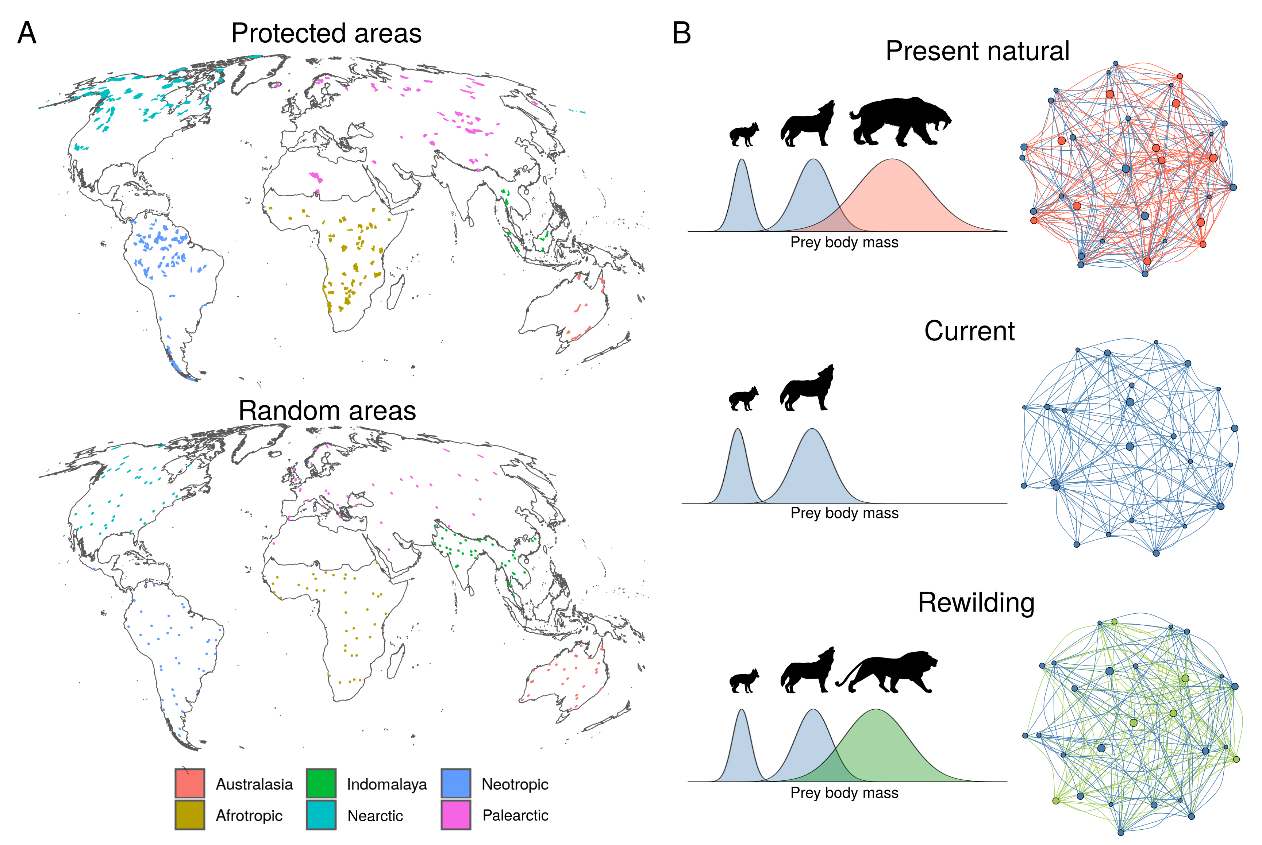

Fig. 1. Conceptual representation of rewiring food webs via trophic rewilding. A) The protected areas and random areas ≥ 5,000 km2 are coloured by the six biogeographic realms considered for trophic rewilding of terrestrial mammals. We excluded Antarctica because no terrestrial mammals live there and Oceania because no terrestrial protected areas larger than ≥ 5,000 km2 are found there. B) Network representation of food webs assessed using reconstructions of species assemblages and interactions under three modelling scenarios: present natural (communities in the absence of human), current (present day communities), rewilding (communities given reintroduction of living mammals and introduction of funcitonal analogues for extant mammals). Species are shown as circles and predator-prey interactions as lines. Red color show the species and interaction that are lost in current conditions. Green color show the species reintroduced or replaced by functional analogues and the interactions rewired. Blue color show species and interactions common to all scenarios.

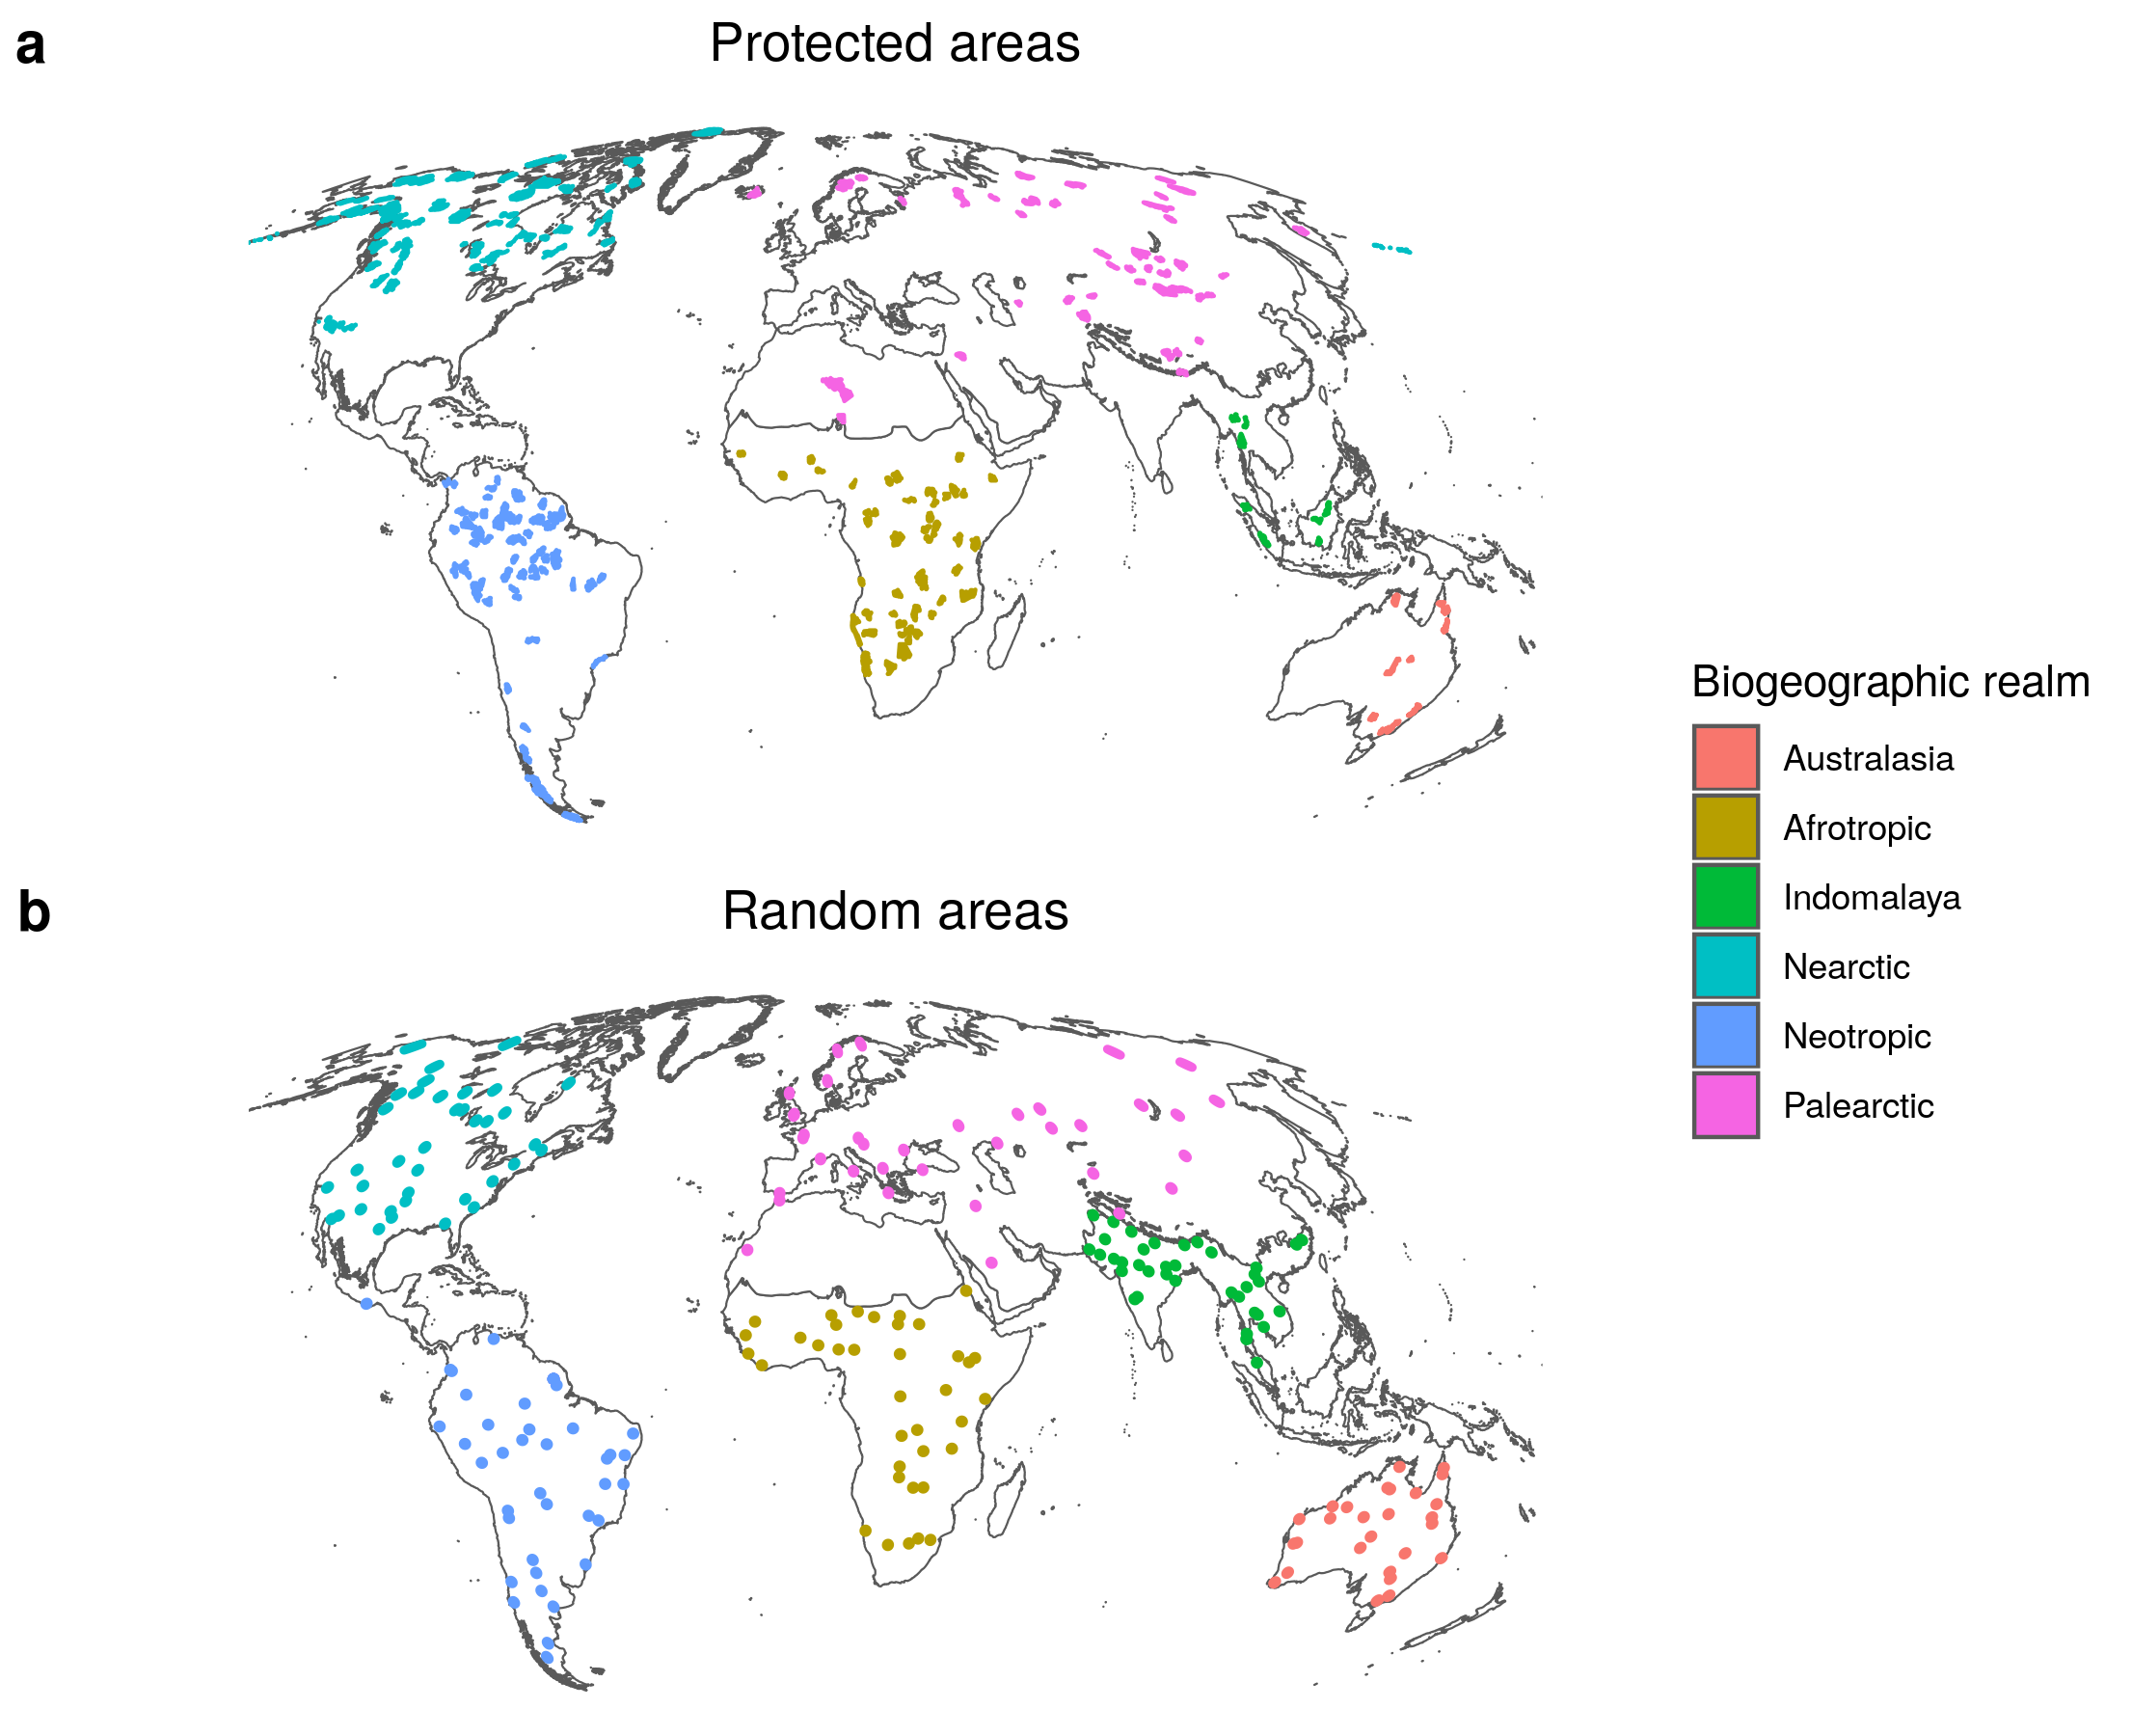Fig. 1 (alternative version): Locations ≥ 5,000 km2 were we simulated trophic rewilding. a, Protected areas and with IUCN management category I-II. We excluded Antarctica because no terrestrial mammals live there and Oceania because no terrestrial protected areas larger than ≥ 5,000 km2 are found there. b, Random areas, counter-factual locations of ≃ 5,026 km2 generated at random for each Biogeographic realm, used to assess if trophic rewilding was affected by geographic biases of the protected areas. Colours show the biogeographic realms. Random areas are displayed larger than their real extent for easier visualization.

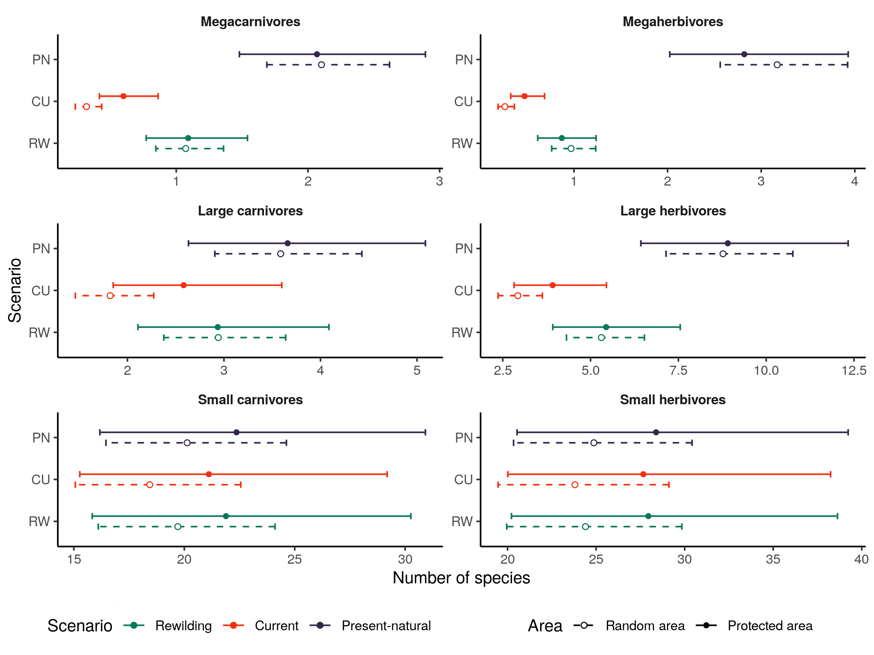

Figure 2: Model estimates of the number of species per trophic level from generalised linear mixed models (GLMMs) for three scenarios: PN, present-natural (blue); CU, current (red); and RW, rewilding (green). Circles show the estimated means from the GLMMs and lines and vertical bars the 95% confidence intervals for protected areas (closed circle and solid lines) and for random areas (open circle and dashed lines). The GLMMs accounted for variation across biogeographic realms and food webs**.** Trophic levels were defined following of Malhi et al. (2016) as: megacarnivores (≥ 100 kg), large carnivores (21.5 – 99 kg), small carnivores (< 21.5 kg), megaherbivores (≥ 1,000 kg), large herbivores (45 – 999 kg), and small herbivores (< 45 kg).

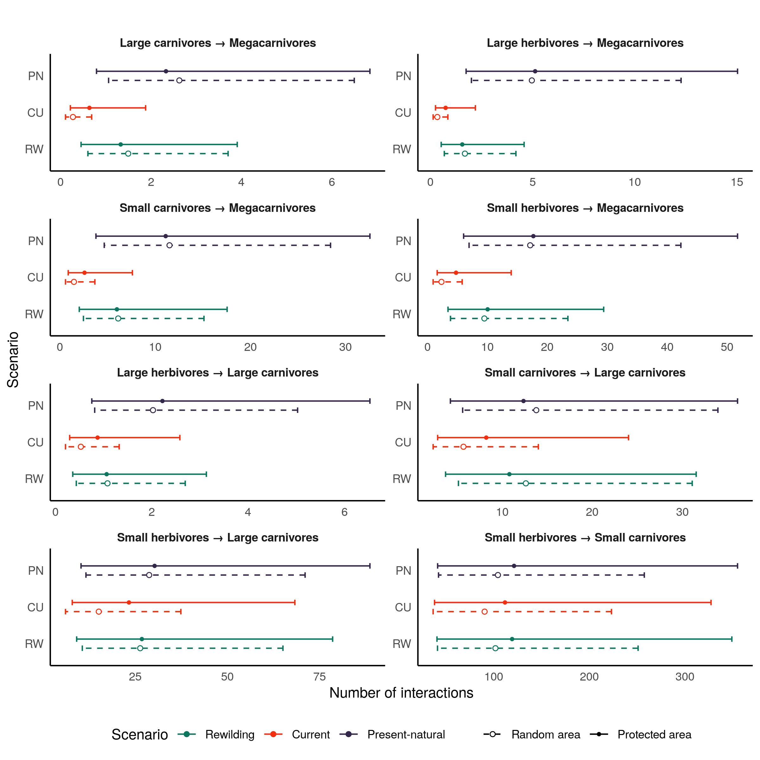Figure 3. Model estimates of the number of predator-prey interactions between each trophic level from generalised linear mixed models (GLMMs) for three scenarios: PN, present-natural (blue); CU, current (red); RW, rewilding (green). Circles show the model estimates and lines and vertical bars the 95% confidence intervals for protected areas (closed circle and solid lines) and for random areas (open circle and dashed lines) are shown.The GLMMs accounted for variation across biogeographic realms and food webs. For the definitions of trophic levels see the caption of Fig. 1. Megaherbivores were free from predation in all food webs.

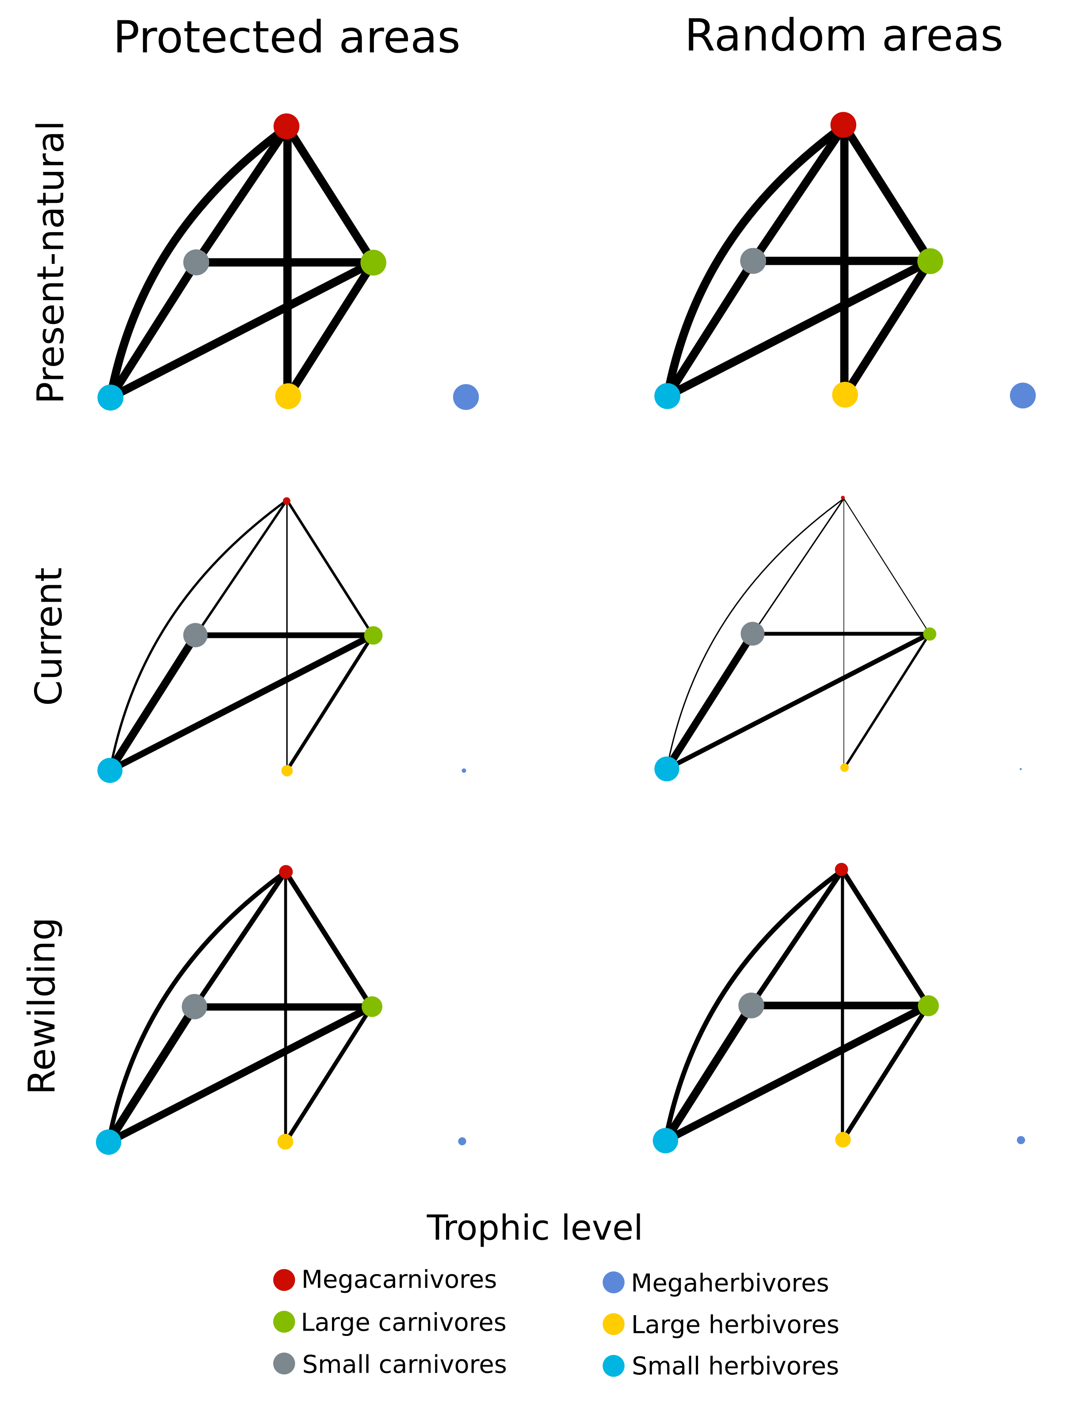Figure 4: Network representation of the mean estimates from GLMMs for the food webs in the three scenarios. Circles are trophic levels and lines the predator-prey interactions. Circles and lines are normalised for the present-natural values, our reference baseline. Circle colours show the trophic levels.

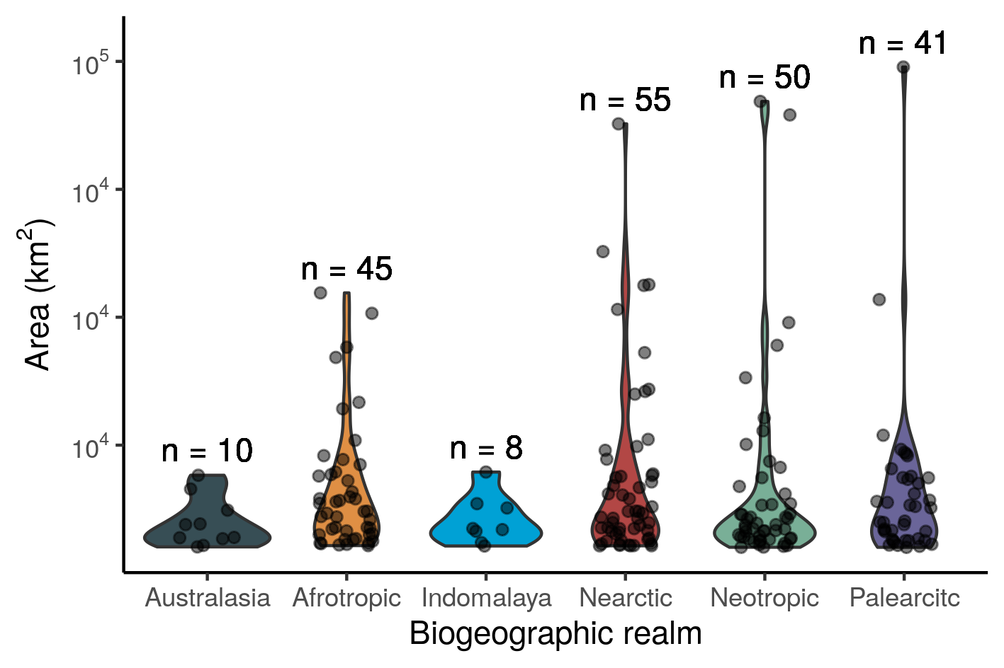

Figure 5: Number (n) and extension of the protected areas studied for the six biogeographic realm. Violin plots show the distribution of area size per realm and points the individual protected areas.

|  |  |  |  |  |  |
| --- | --- | --- | --- | --- | --- |
| Biogreographic realm | Number of protected areas | Minimum extent (km2) | Mean extent (km2) | Median extent (km2) | Maximum extent (km2) |
| Australasia | 10 | 5,112 | 9,798 | 8,217 | 19,111 |
| Afrotropic | 45 | 5,368 | 16,032 | 12,034 | 54,762 |
| Indomalaya | 8 | 5,290 | 10,327 | 8,594 | 19,739 |
| Nearctic | 55 | 5,290 | 18,163 | 11,654 | 87,793 |
| Neotropic | 50 | 5,039 | 16,045 | 9,422 | 92,180 |
| Palearctic | 41 | 5,031 | 15,483 | 10,154 | 98,902 |